Designing A Sales Dashboard in Excel
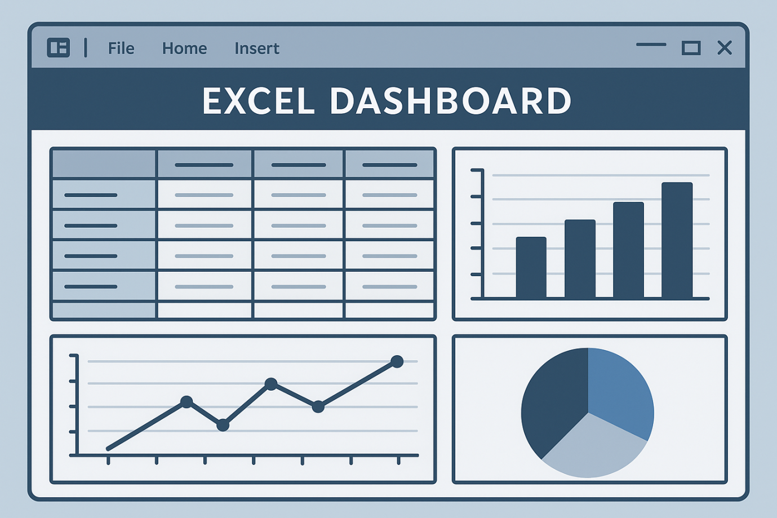
A simplilearn project

By :-
Kaveri

Table of Content
Task 1- Problem Statement.
Task 2- E- Commerce file.
Task 3- Basic Designing of Dasboard.
Task 4- Creation of timeline.
Task5- Creation of Combo Box for Product Category and product in the dashboard.
Task 6- Pivot Tables and Charts of SALES and PROFIT (Month wise and Region Wise)
Task 7- Create Product Category Wise Sales.
Task 8- Slicers (Region, Product and Product Category)
Task 9- Creation of Dashboard.

Task 1
Problem Statement
A company wishes to add user control for product categories for customers to choose a category and view the trend month-by-month and product-by product. They will use Excel to analyze sales based on product categories and create a sales dashboard that breaks down sales by product category.

Task 2
E- Commerce file

We have the raw data available. Dashboards and pivot tables are created using this raw data. I renamed it as “Data List”.
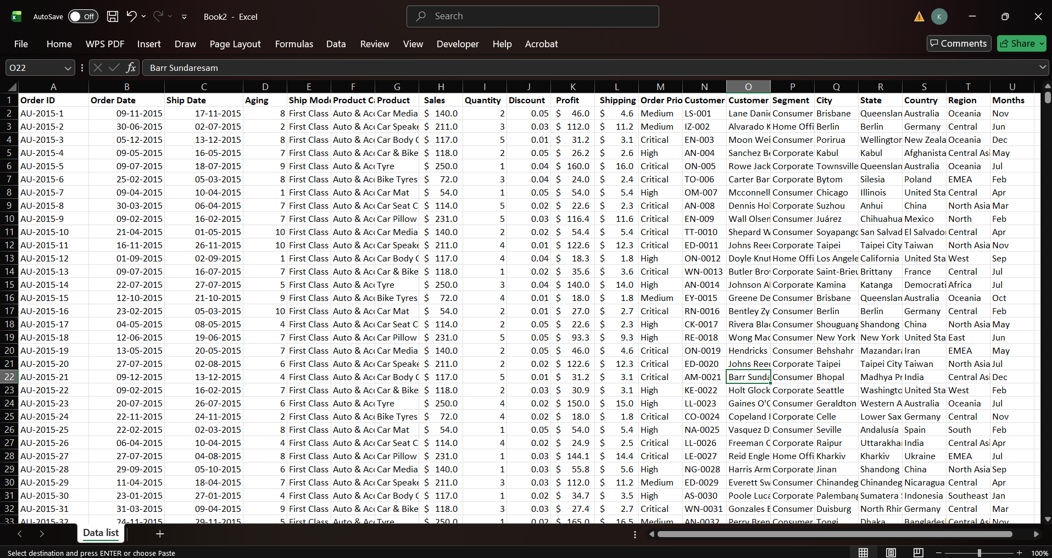

Task 3
Basic Designing of Dashboard
Interactive dashboards are very important. We click on any region, month or item and watch as the data updates instantly to reflect our selection. Charts and key matrix changes in real time to give us deeper insights into the data.
We have raw data available. Let’s create a new sheet for our dashboard. Right click and rename it as “dashboard”. Move the data sheet to the end by dragging the sheet tab. Lets go the dashboard sheet.
- Go to insert tab.
- Click shapes.
- Select rounded rectangle shape.
- Draw the outline.
- Press ctrl+d to duplicate the shape.
- Create another box in lighter shade and reposition it.
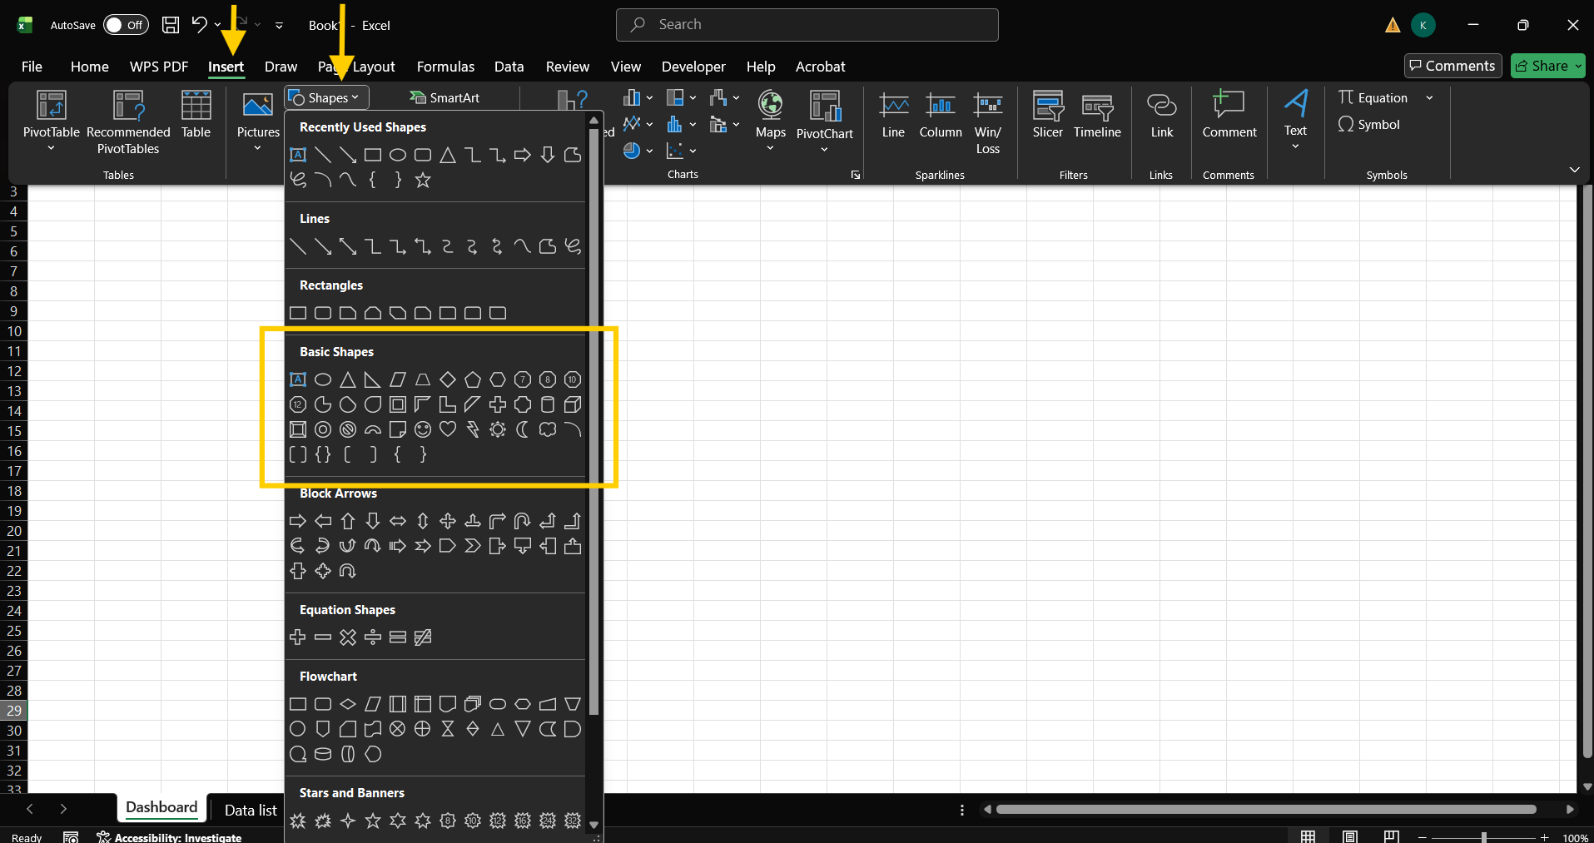

Task 4
Creation of timeline
Go to the data list and select data, go to the insert tab and go to “pivot table” and choose “new worksheet” where pivot table appears.
Create monthly timeline.
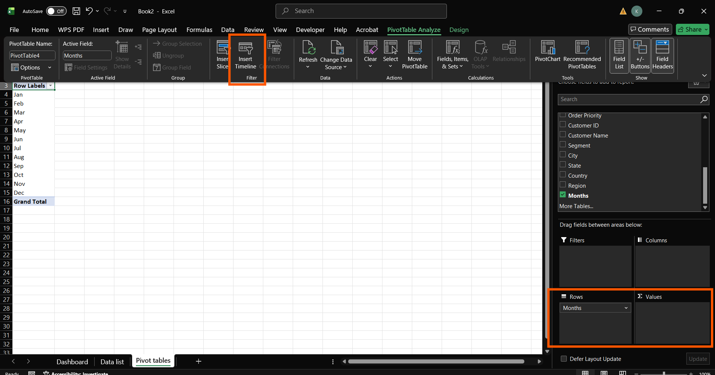
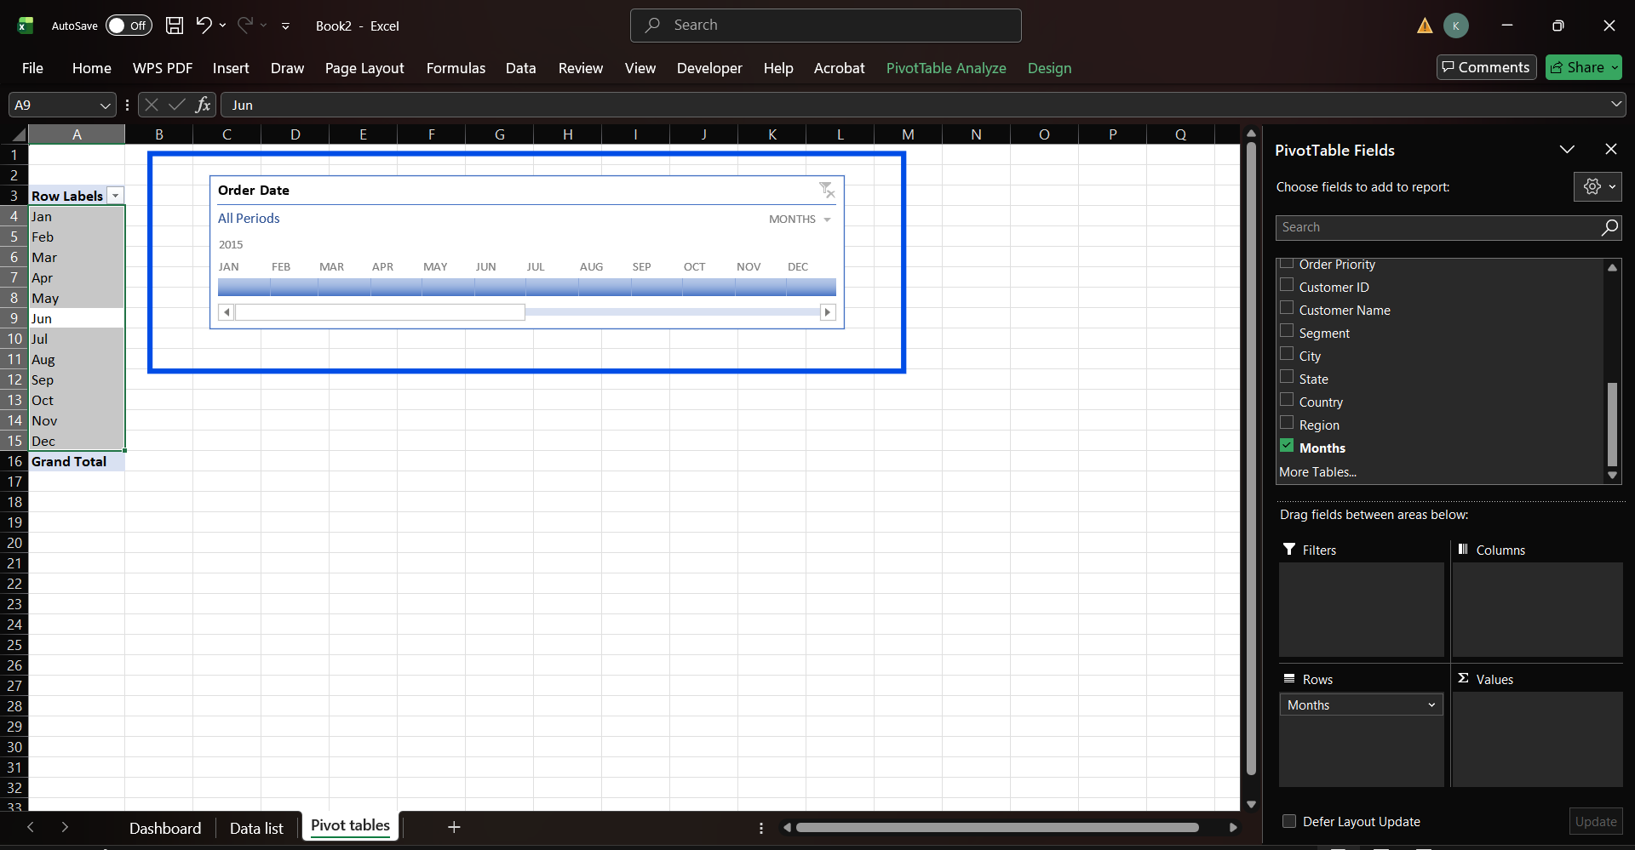

Task 5
Creation of Combo Box for Product Category and product in the dashboard.

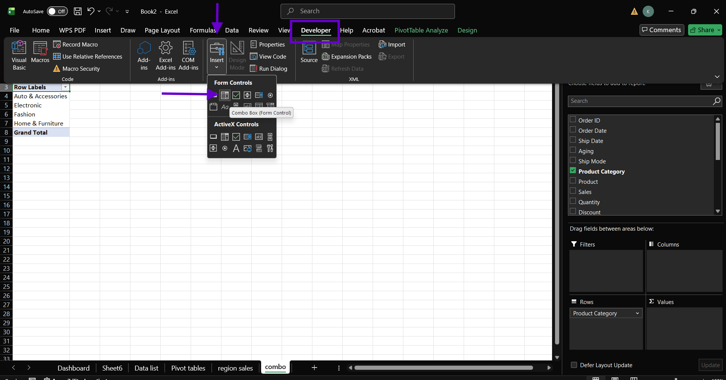

Steps
- Select data from the “data list”.
- Go to the insert tab.
- Go to pivot table.
- Create pivot table in a new worksheet.
- Go to Developer Tab.
- Insert Combo box.
- Create Combo box for “Product category” and “Product”.
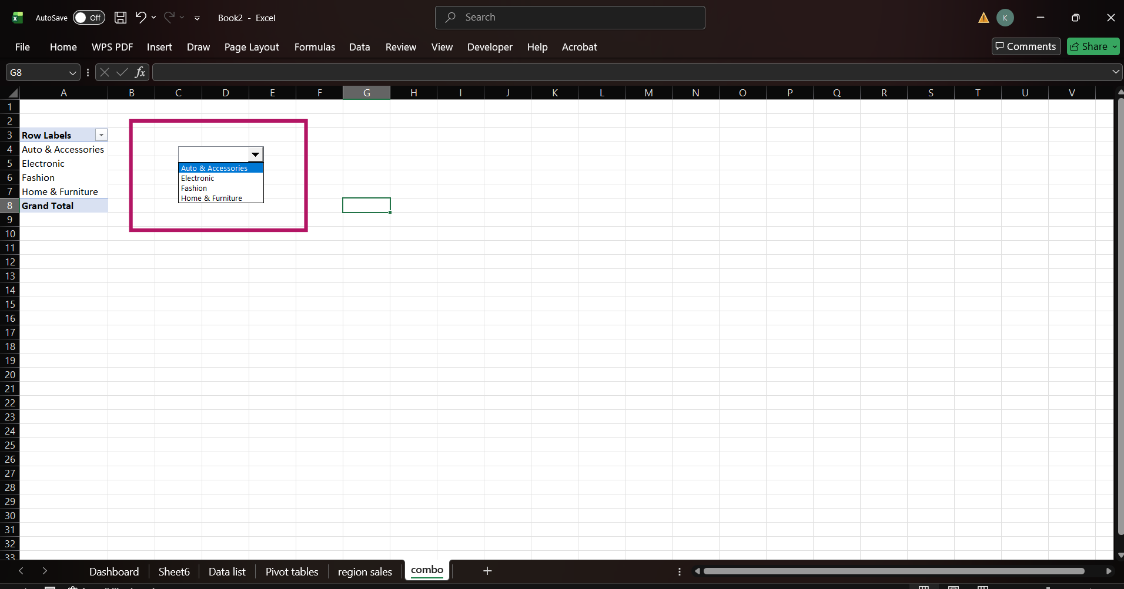

Task 6
Pivot Tables and Charts of SALES and PROFIT (Month wise and Region Wise)
- Region wise sales.
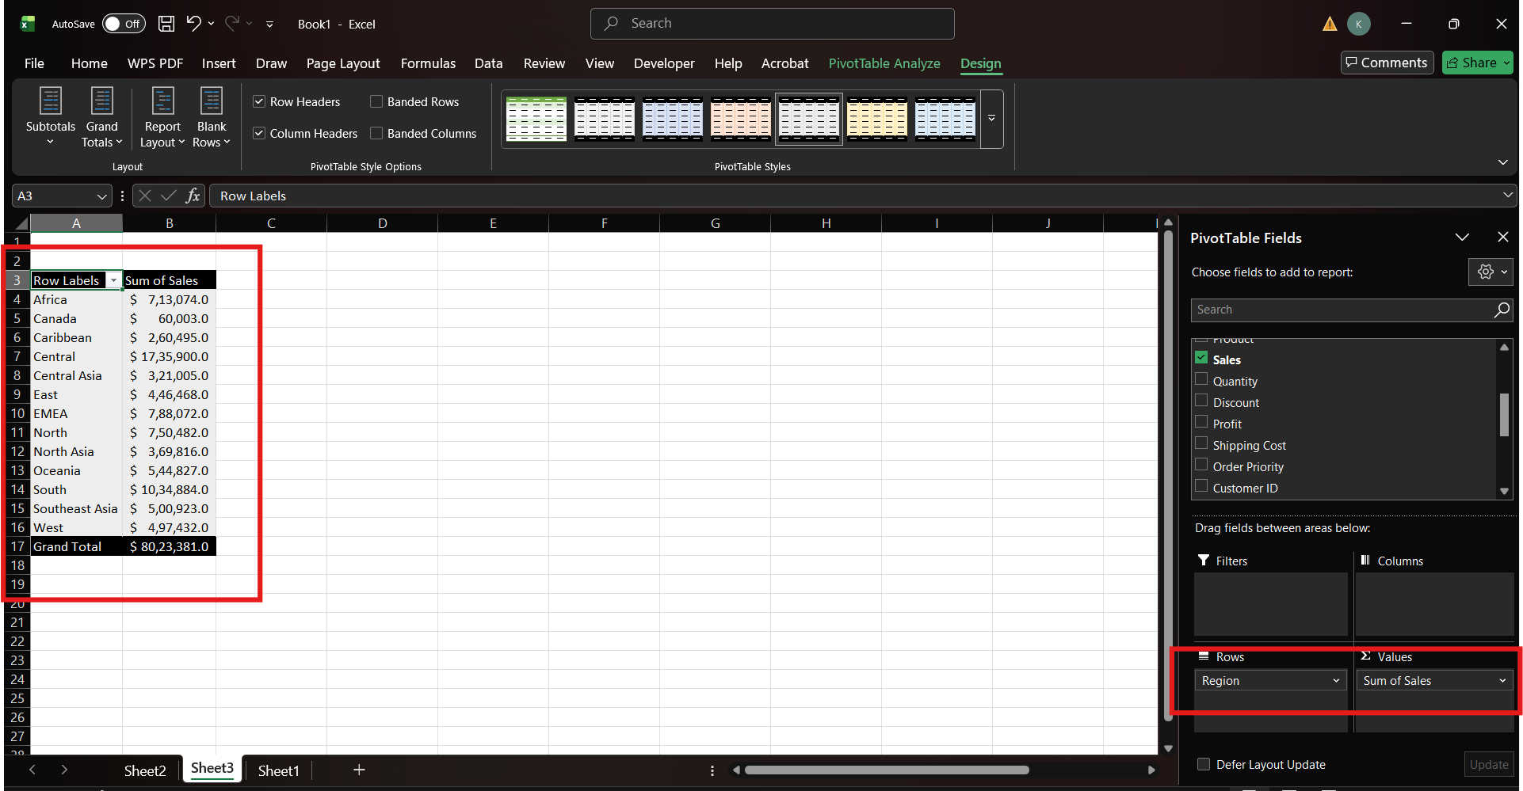
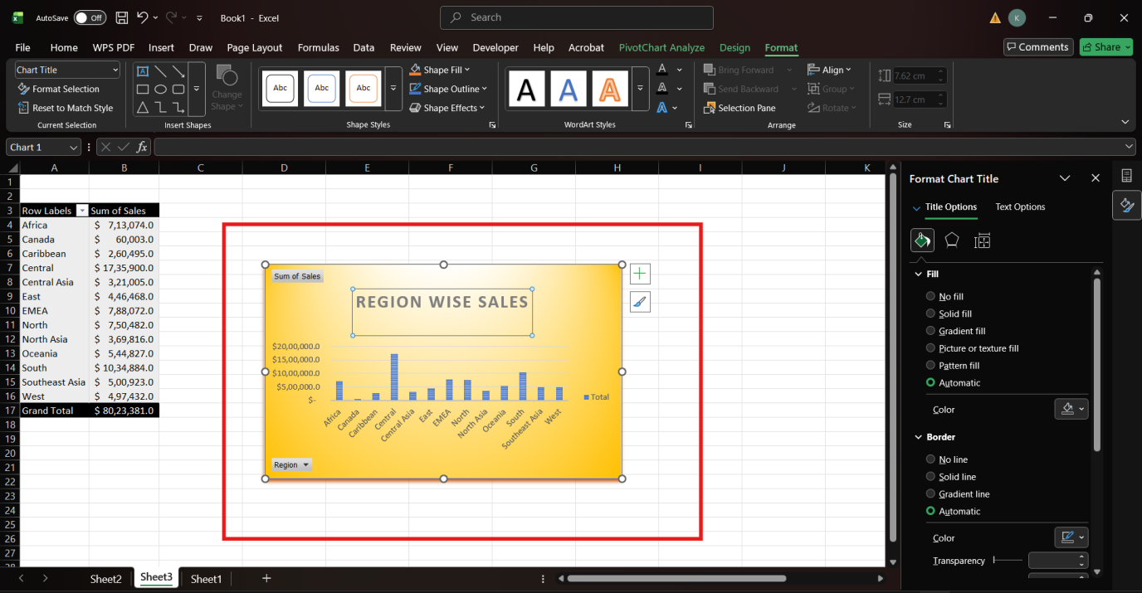
Steps
- Insert a pivot table from the “data list”.
- Drag Region to rows and sales to value panel.
- Pivot table is created.
- Go to “pivot chart Analysis”.
- Go to “Pivot Charts”.
- Create a chart and format it.

- Month wise sales and profit.
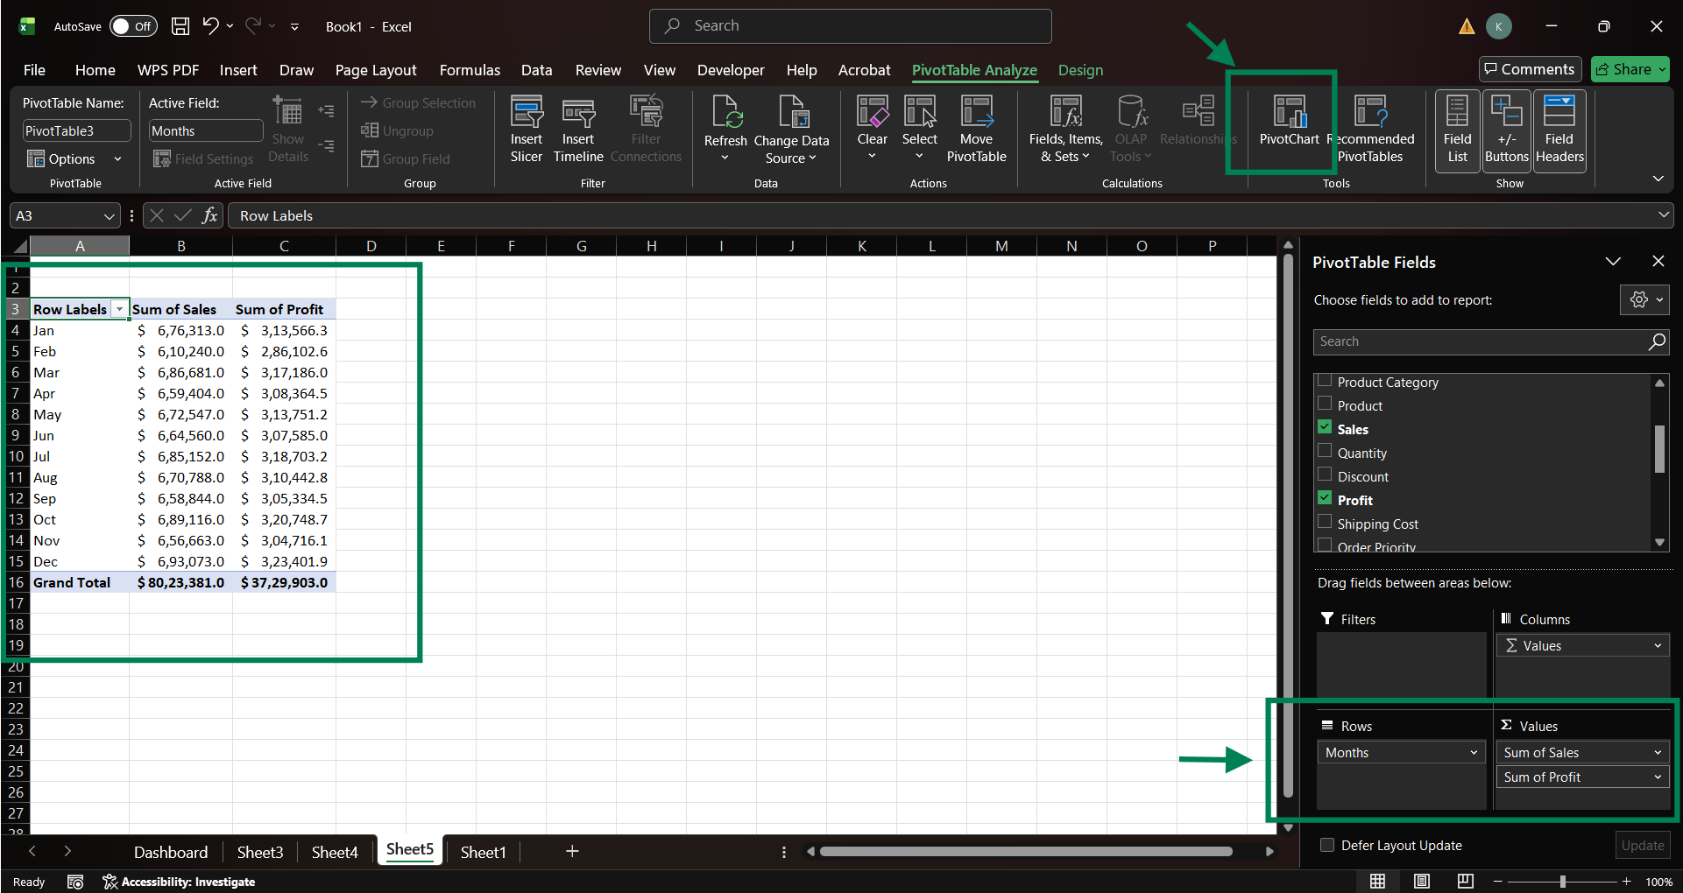
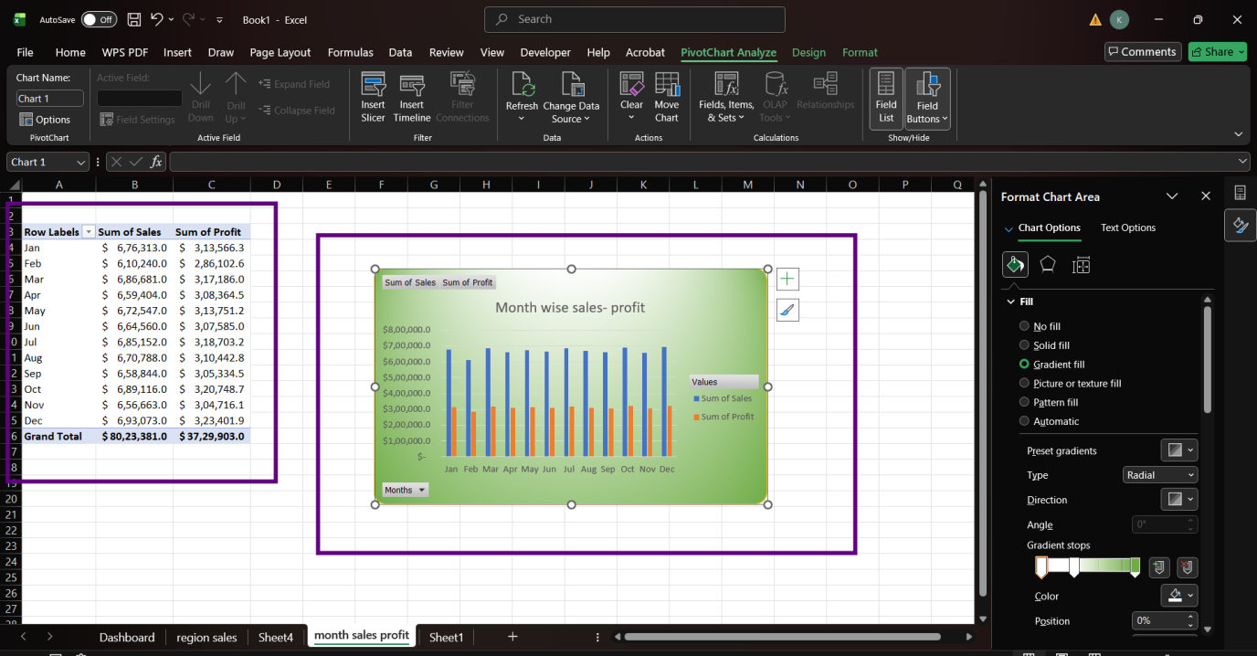
Steps
- Insert a pivot table from “data list”.
- Drag month to row and sales and profit to values panel.
- Pivot table is created.
- Go to Pivot table analyze.
- Create pivot chart and format it.

Task 7
Create Product Category Wise Sales.
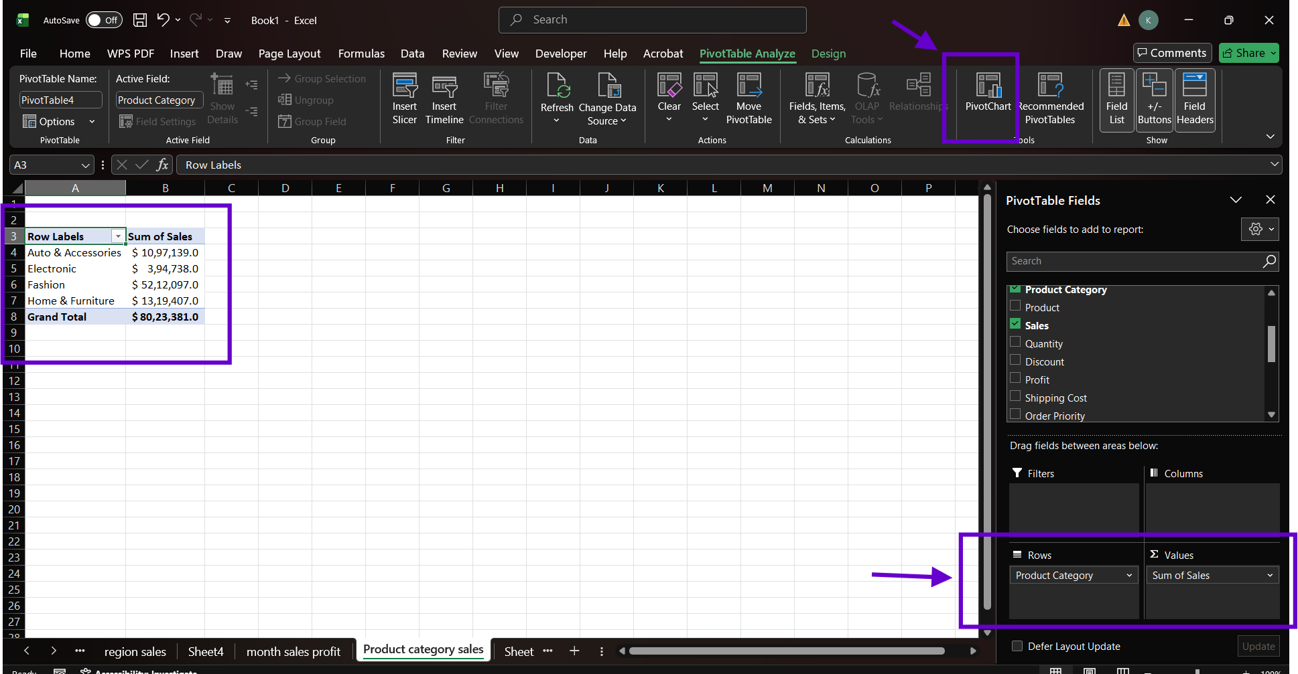
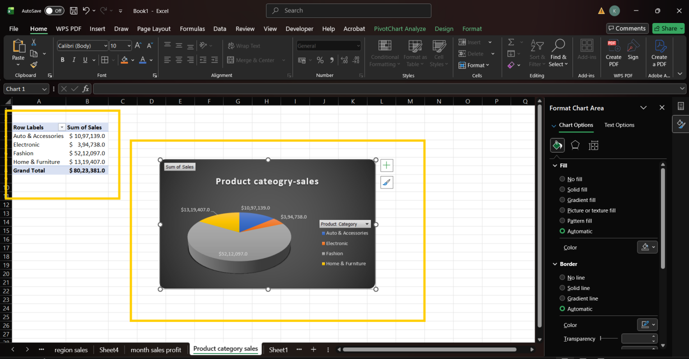
Steps
- Insert “Pivot Table” to the data list.
- Drag “Product Category” to row and “Sales” to value panel.
- Pivot table is created.
- Go to the Pivot table Analyze Tab.
- Create Pivot chart and format it as required.

Task 8
Slicers (Region, Product and Product Category)
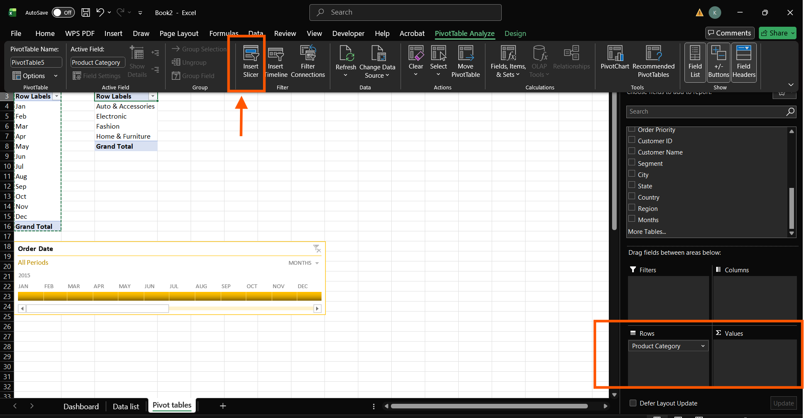
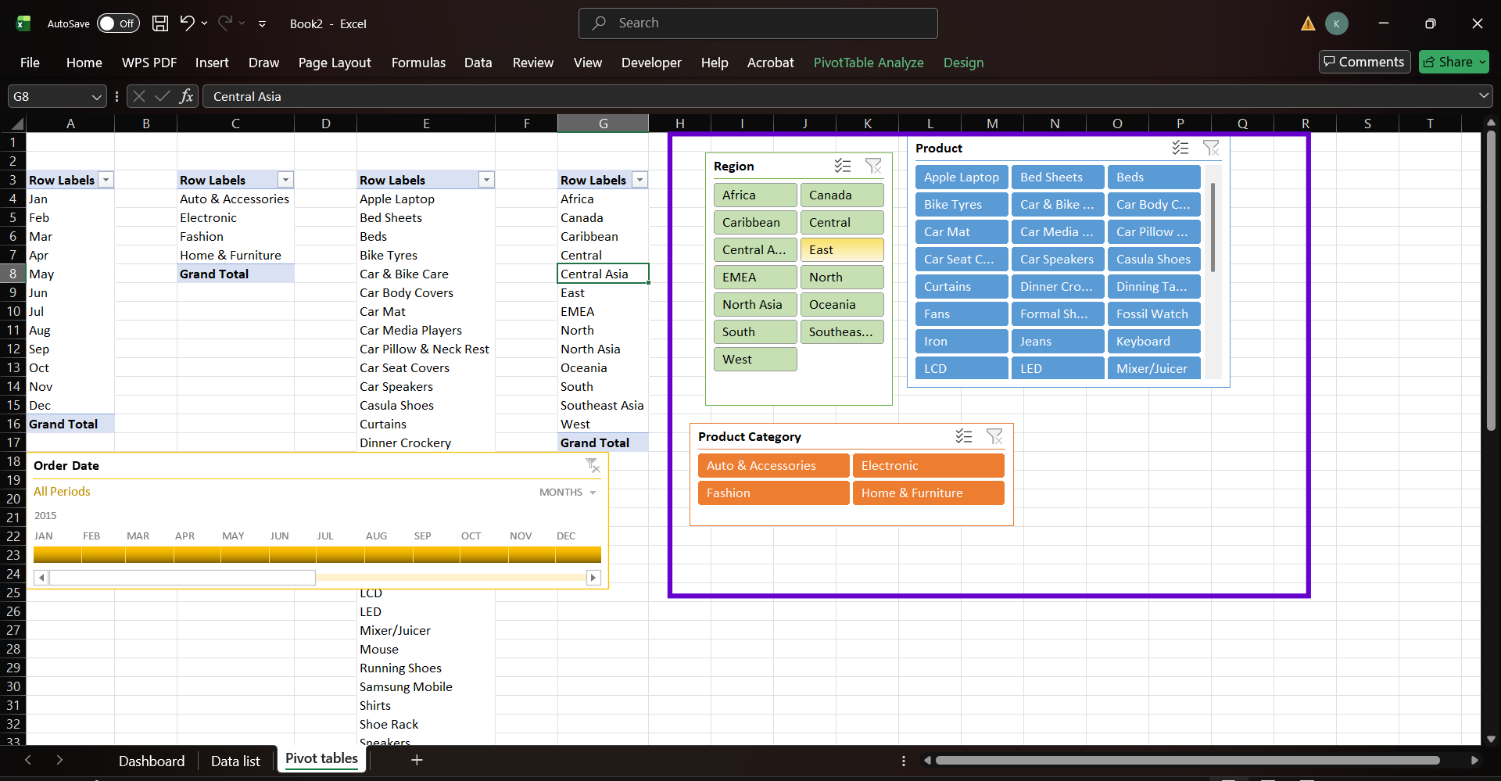

Steps
- In the pivot table, drag product category to the row panel.
- Go to pivot table Analyze Tab.
- Insert Slicer
- Design and format the slicers.
Task 9
Creation of Dashboard
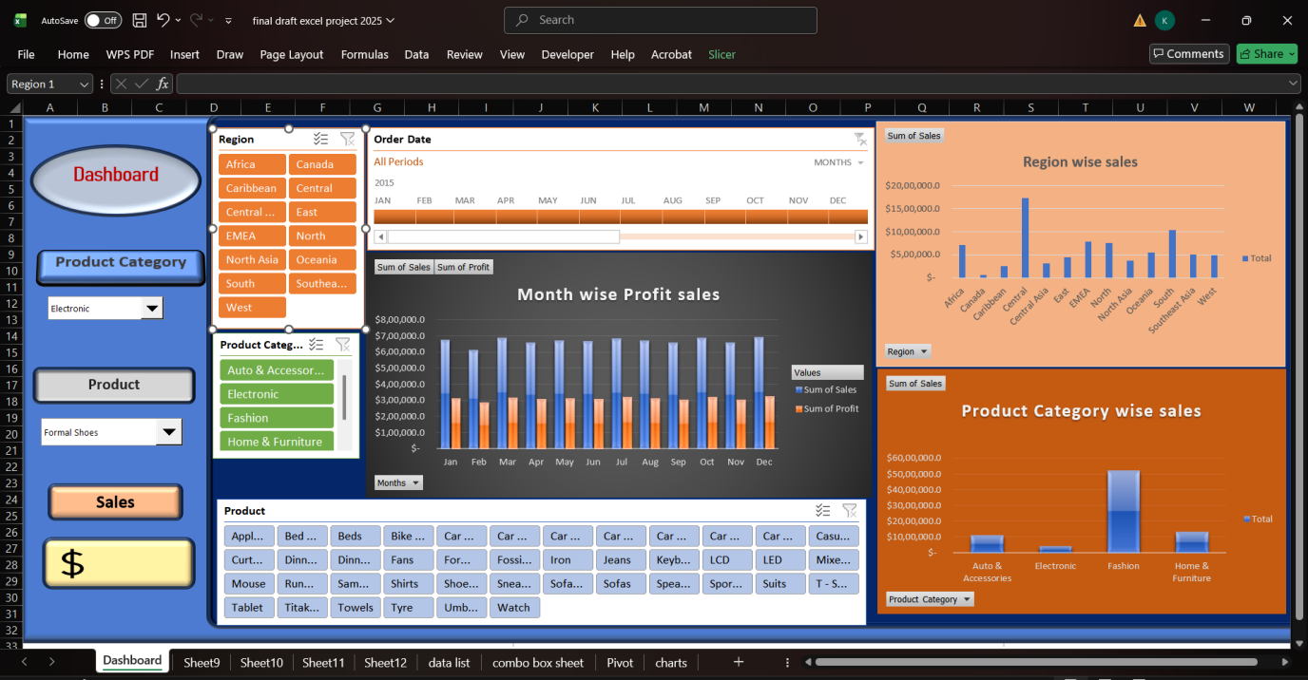
Steps
- A new worksheet is created and renamed as Dashboard.
- Gridlines are removed.
- Shapes are inserted in the workbook, aligned and formatted as required.
- Combo box for product category and product are created to enable the drop down feature.
- Timeline is inserted.
- All the charts are inserted.
- Slicers are inserted.
- A dynamic dashboard is created.

